**GLA UNIVERSITY**



### **JOVAC SUMMER INTERSHIP PROJECT REPORT**

### 

### **AWS CLOUD COMPUTING**

**SUBMITTED BY: UNDER SUPERVISION:**

**AASTHA JAISWAL(2215000008) RAUSHAN KUMAR SINGH**

**FARKANSH GUPTA(2215000653) RUBY PANWAR**

**HARSH PATHAK(2215000747)**

**HABIBA SUBHANI (2215000713)**

**KHUSHI SAHU (2215000910)**

### **PROJECT TITLE:**

**CREATE A EC2 INSTANCE IN MUMBAI REGION AND CREATE ITS LOGS INSIDE THE SERVER AND EXPORT IT TO THE S3 BUCKET.**

### **PROBLEM STATEMENT:**

* **Log Storage and Management.**
* **Log Analysis and Insights.**
* **Log Security and Compliance.**
* **Log Retention and Archiving.**
* **Instance Performance and Resource Utilization.**
* **Log Centralization and Aggregation.**

#### **TECHNOLOGY USED:**

* **Amazon EC2 Instance**
* **AWS CLI**
* **S3 Service**
* **IAM Service**

#### **STEPS SHOULD BE FOLLOWED TO CREATING THE PROJECT:**

* Create an Amazon EC2 Instance
* Create an IAM role
* Attach it to the ec2 server
* Install Cloudwatch logs inside the Server
* Selecting the created logs inside the server
* Creating a S3 Bucket
* Exporting logs to the S3 Bucket

### **Creating EC2 instance Amazon linux:**

* Login into aws account and user a console: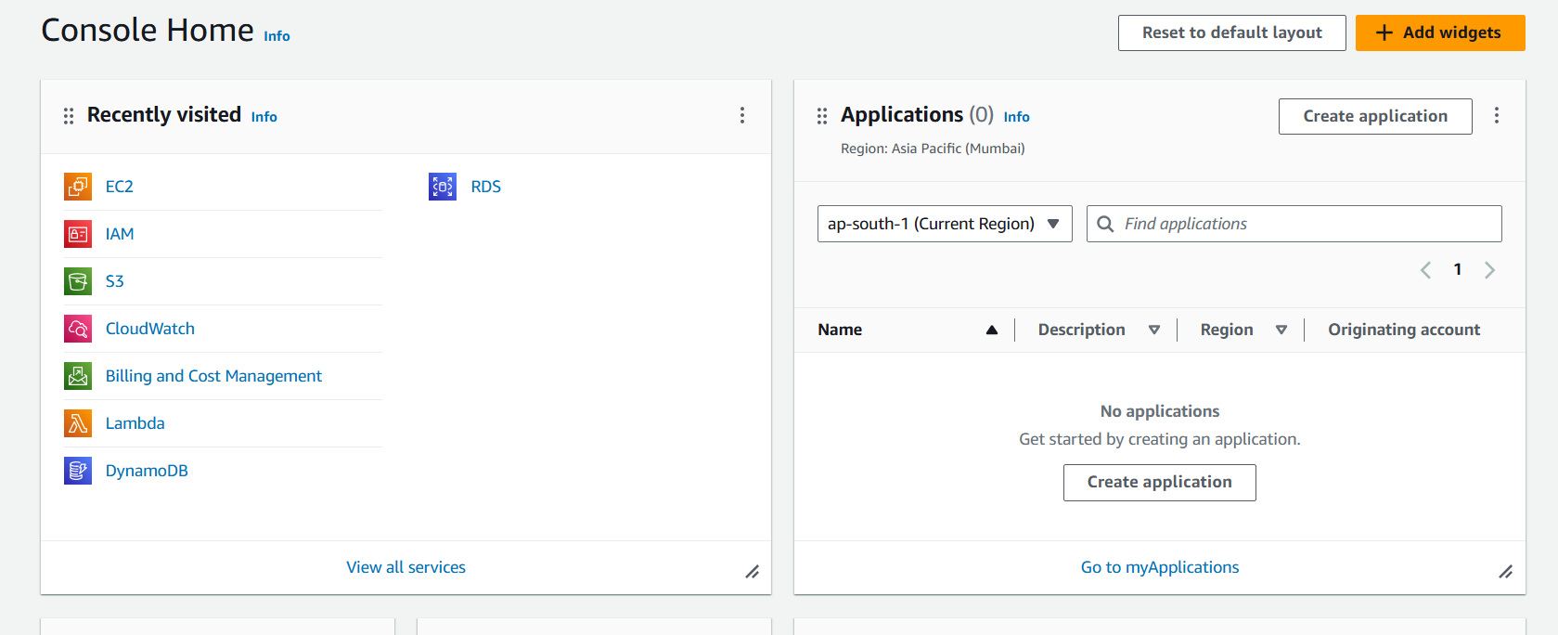
* Go to the EC2 instance for creating the server.

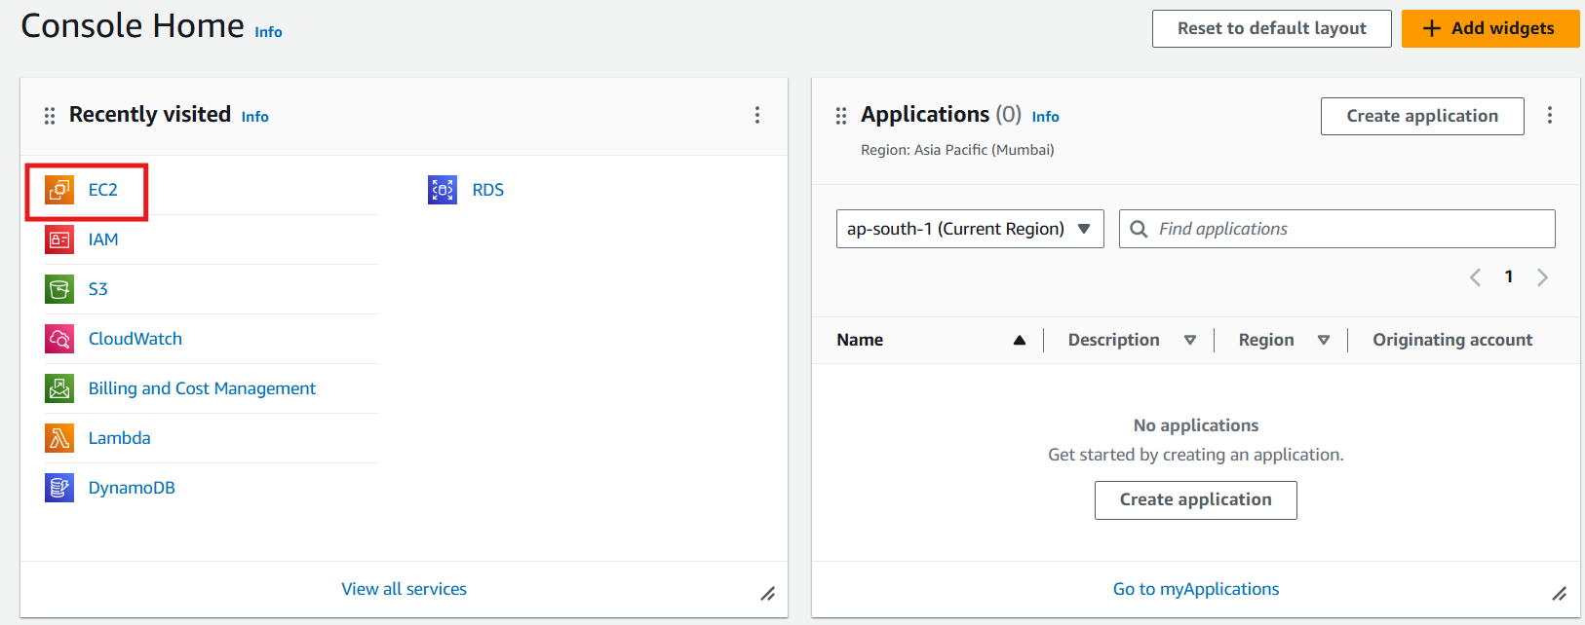

* Click on Instance running option.

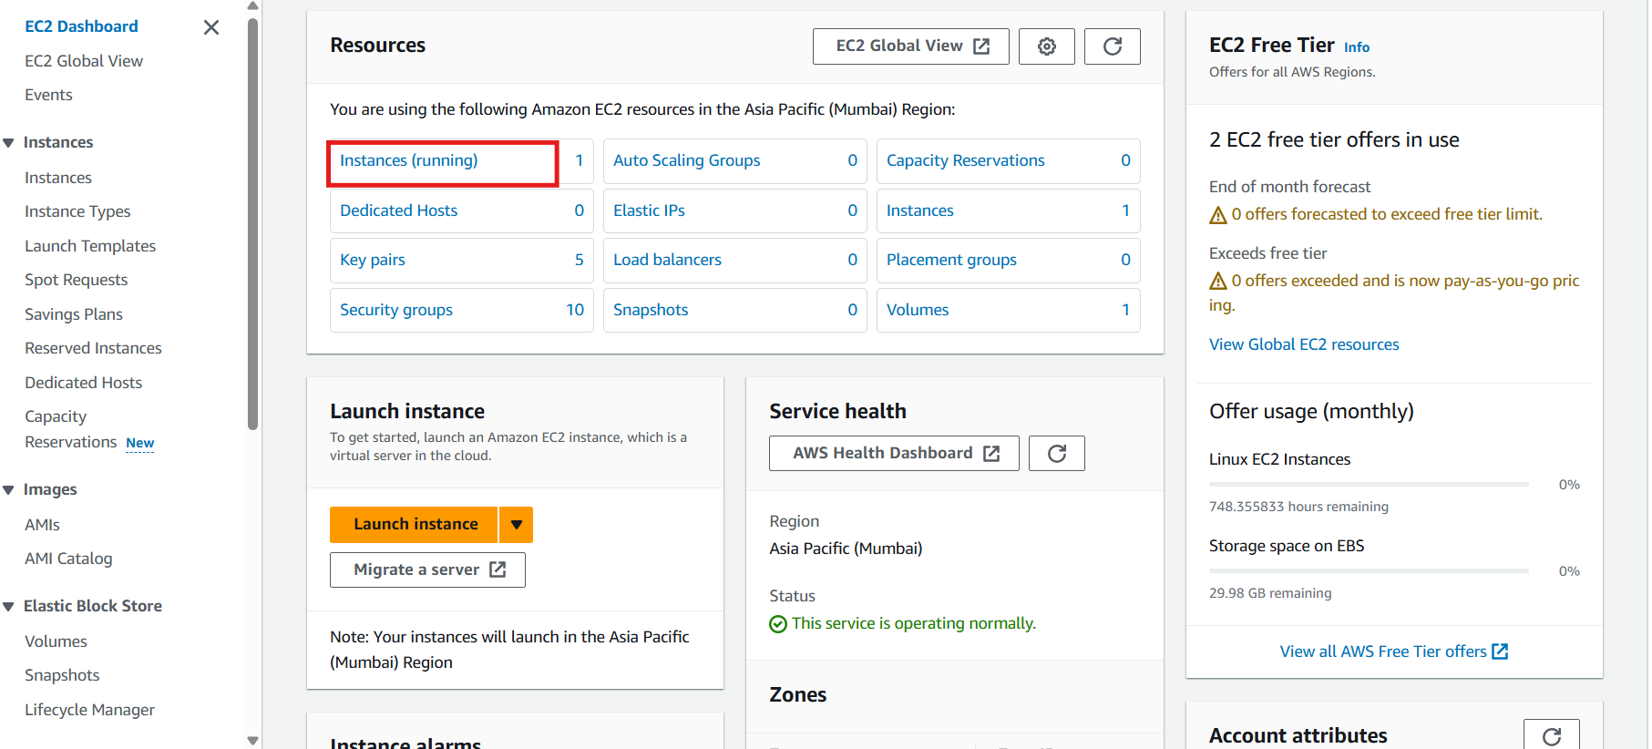

* Click on launch instance option.

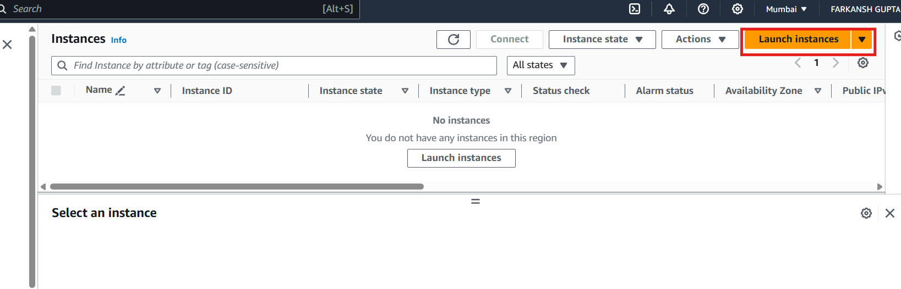

* Give name to server and select AMI like Linux,Ubuntu,Window ,etc…. and Create a key pair and also select Security groups and allow HTTP and HTTPS services to server.

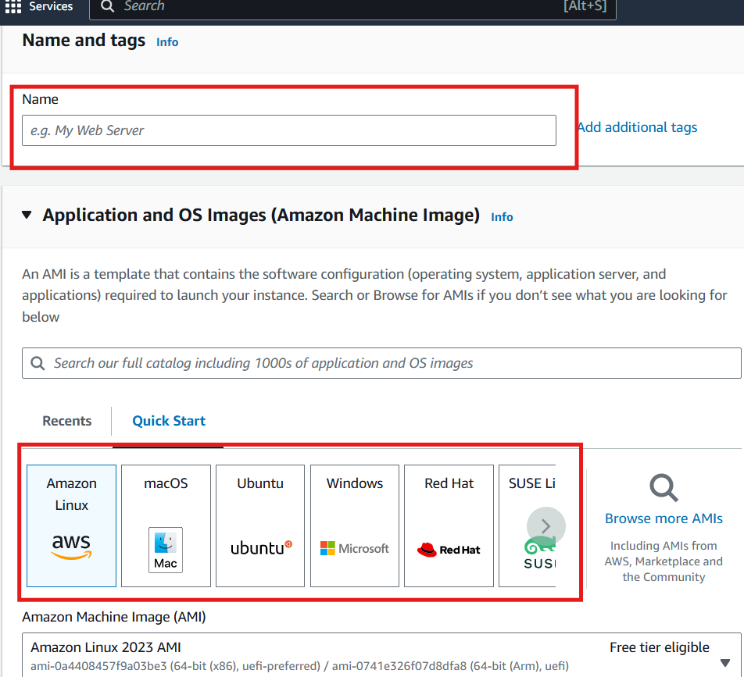

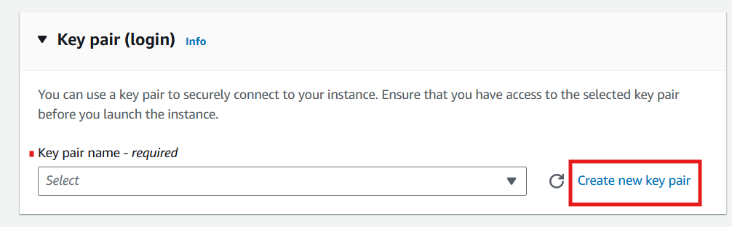

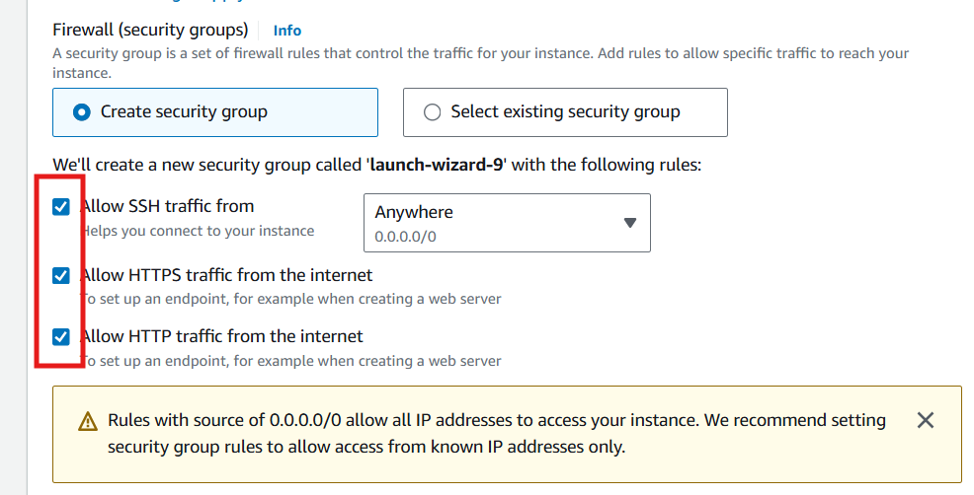

* Now,Click on Launch instance.Your instance is created.

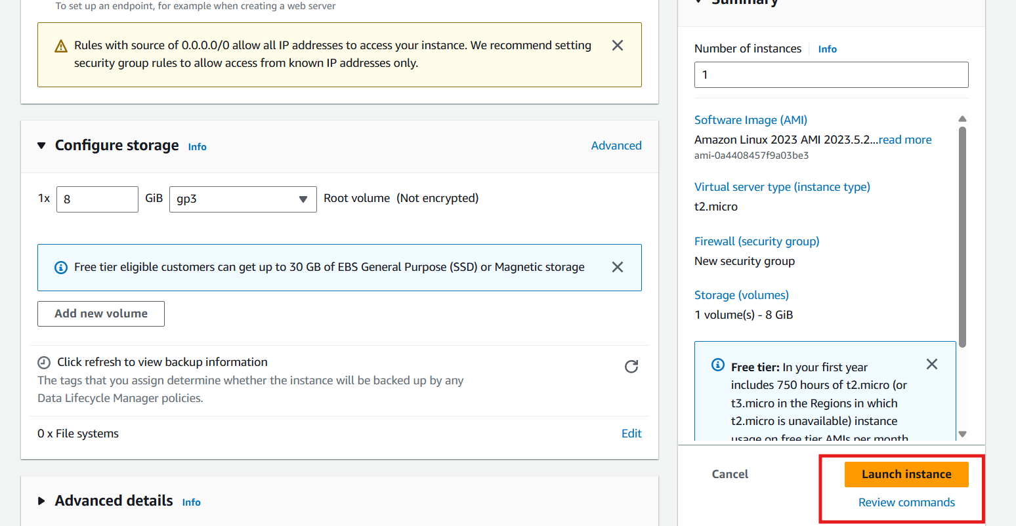

* Your linux server is ready to run.

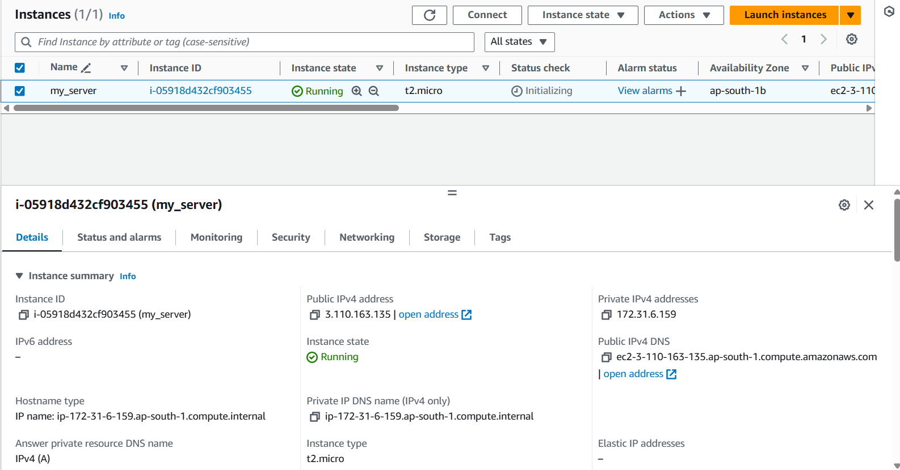

* Create an IAM role policy for logs accessing and Attach with EC2 instance.

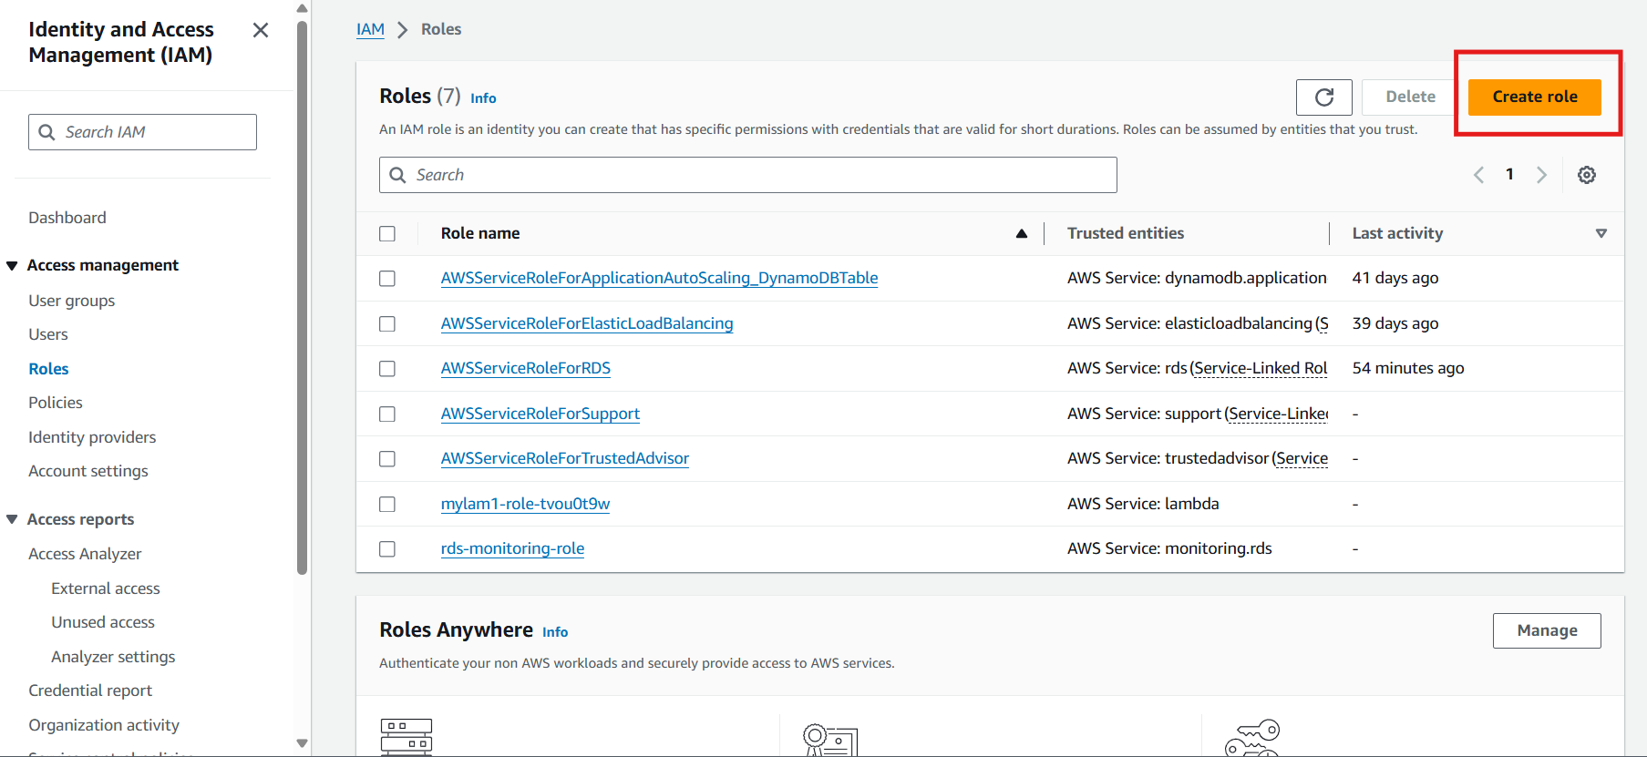

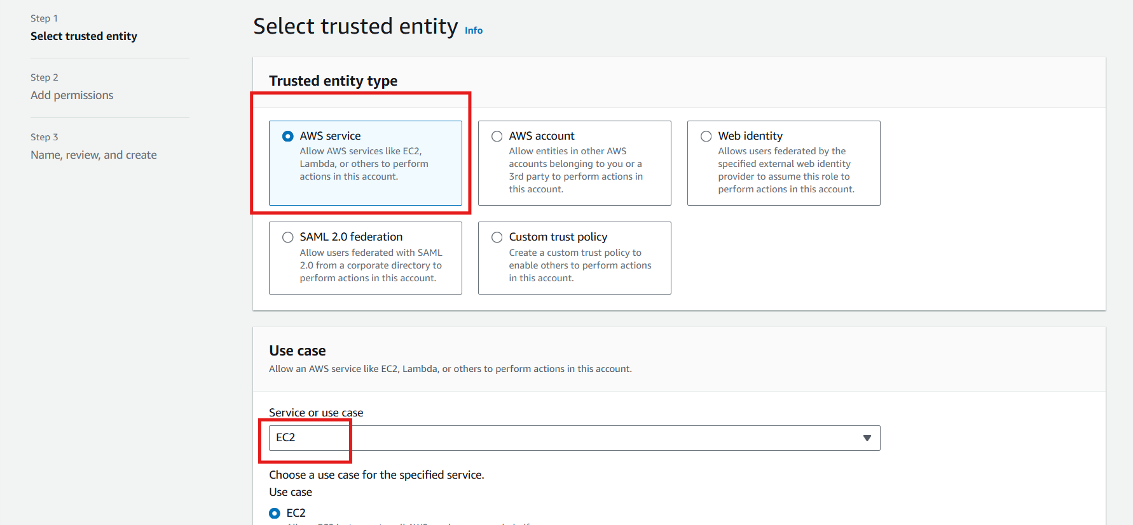

* Add permissions of Cloudwatch logs for accessing logs in linux server.

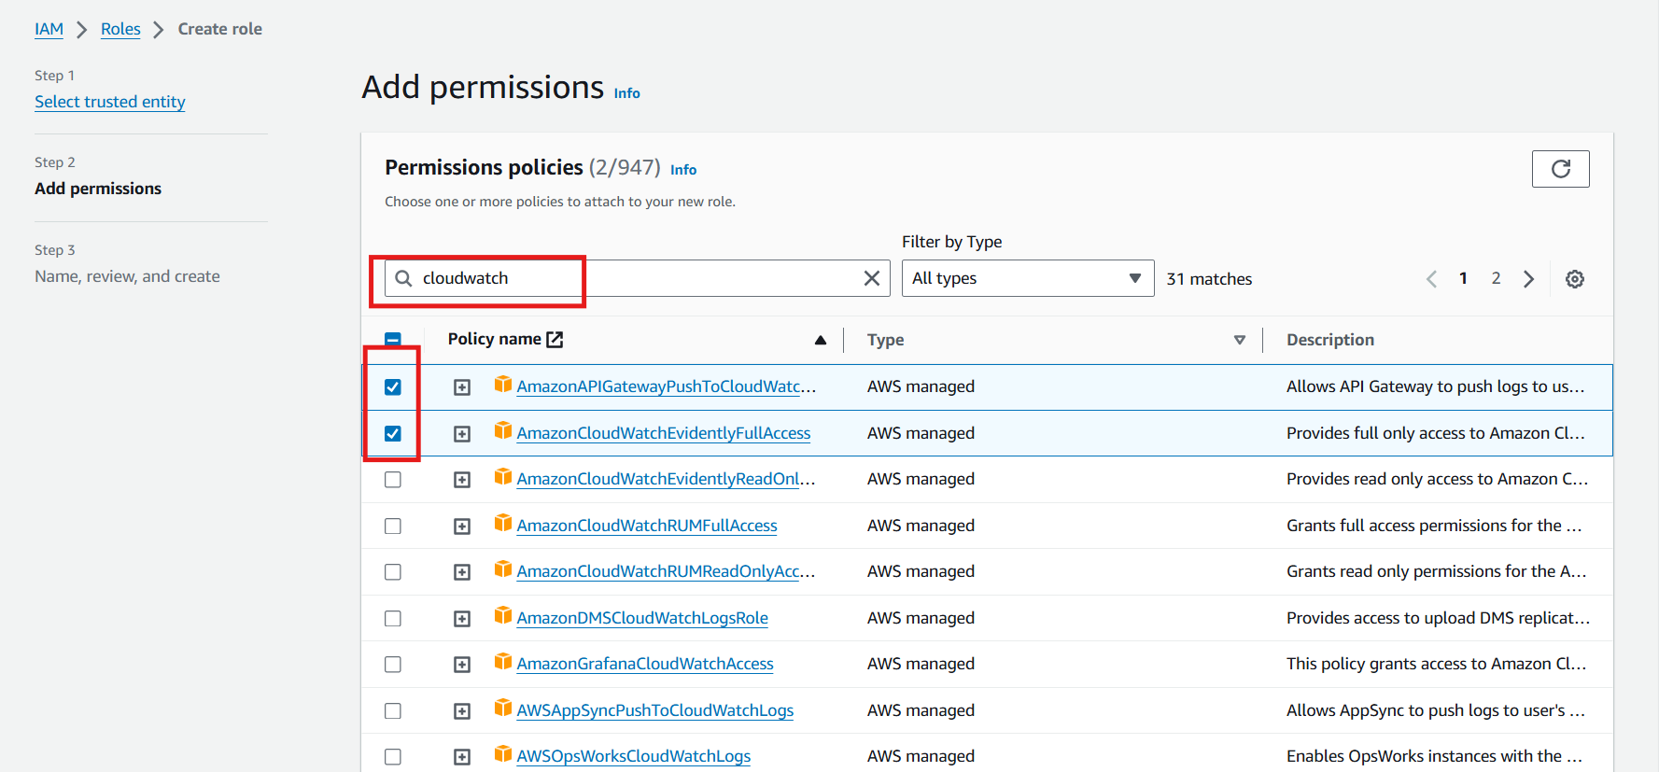

* Give name to the IAM role.

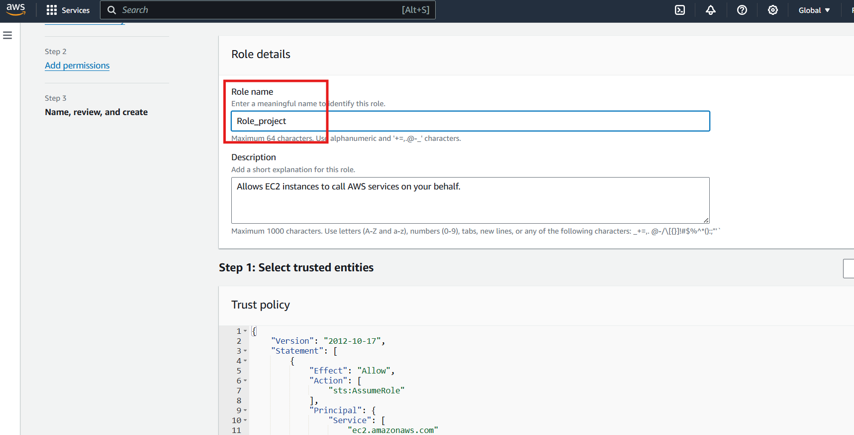

* Your IAM role is created.

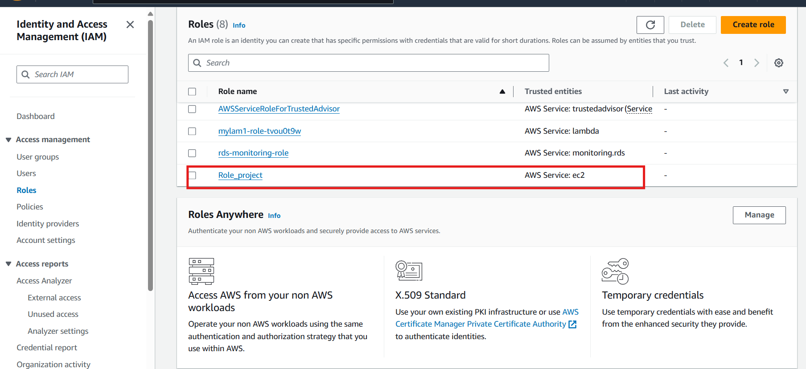

* Attach IAM role with EC2 server.

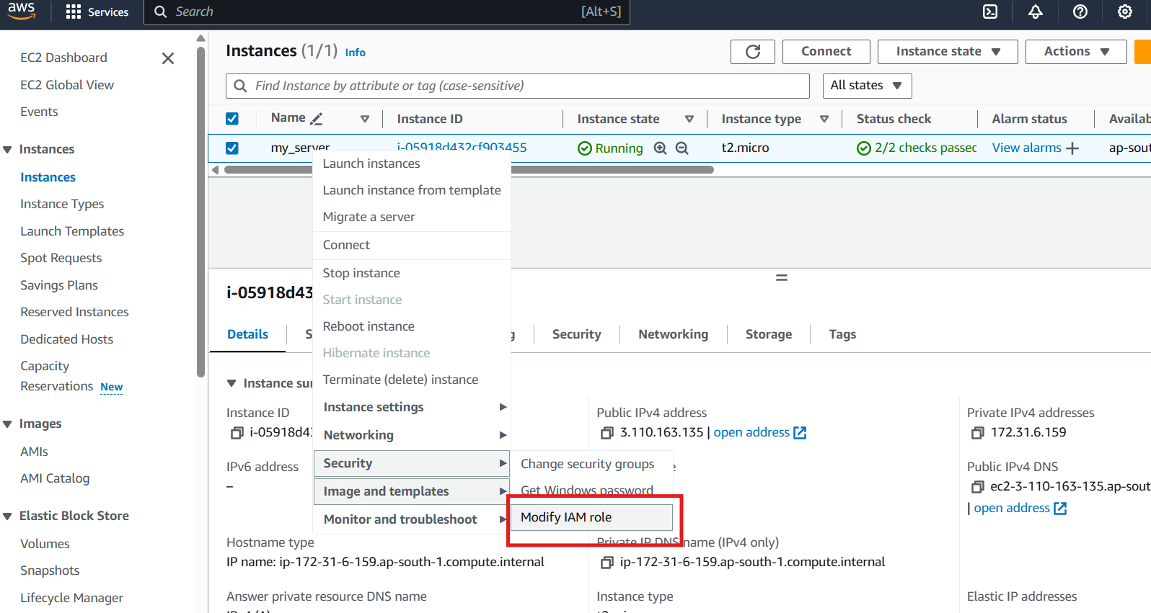

* Select the created role and attach to the server.

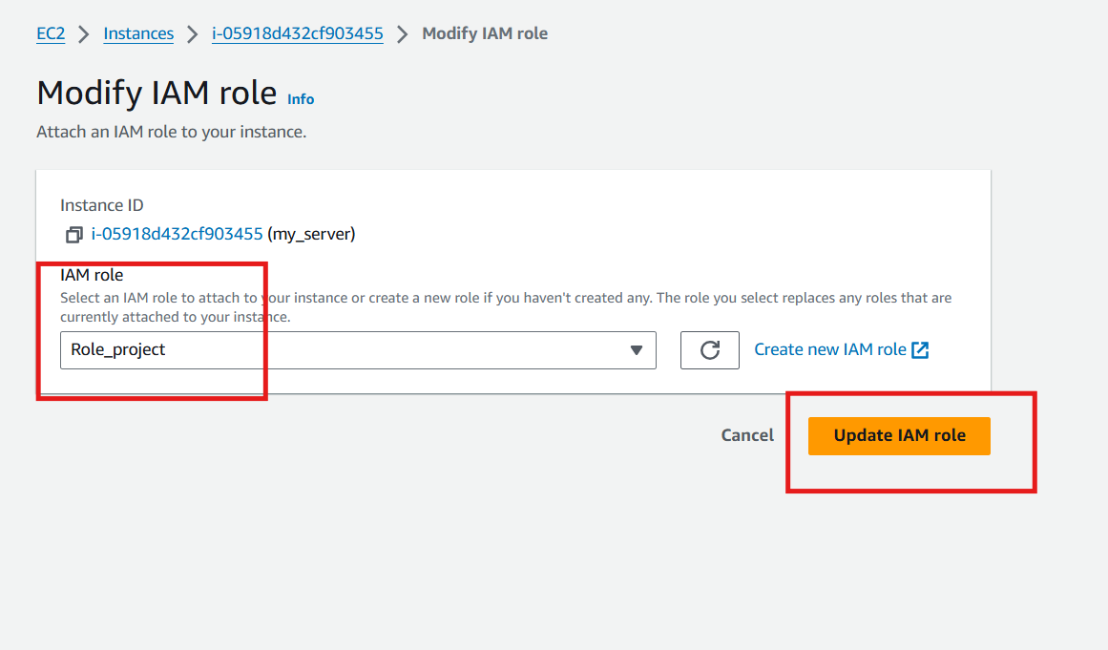

* Connect the server.

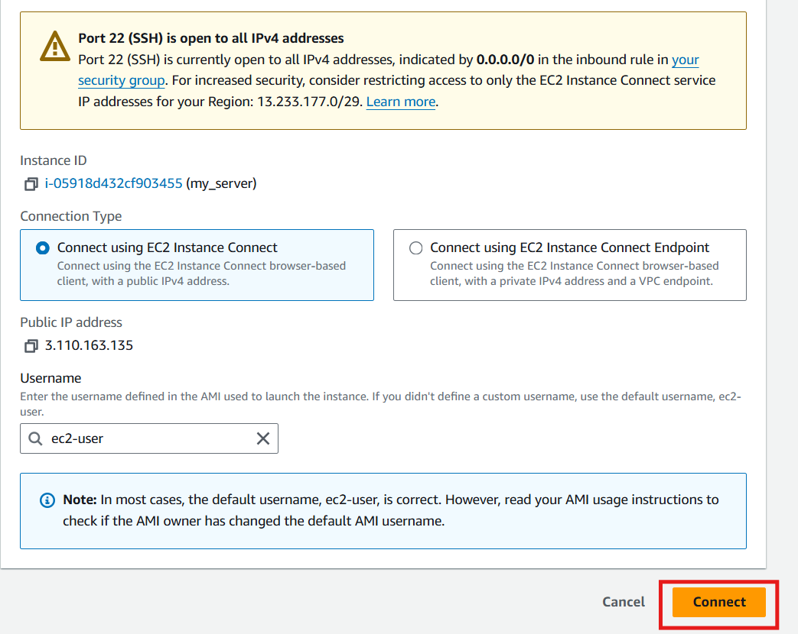

* Now,Your server is in running state.

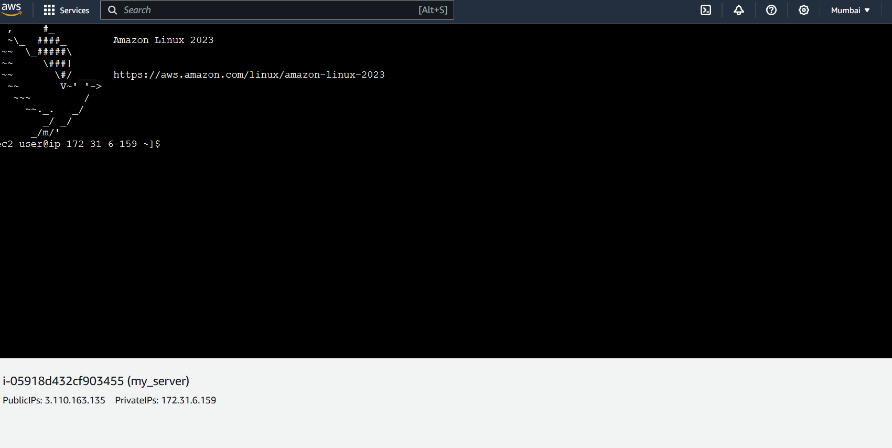

* Run the following commands to access the logs in the linux server.
* sudo yum update -y
* sudo yum install -y awslogs
* cd /etc/awslogs/awslogs.conf
* cd /etc/awslogs/awscli.conf
* **sudo service awslogs start**
* **sudo systemctl start awslogsd**

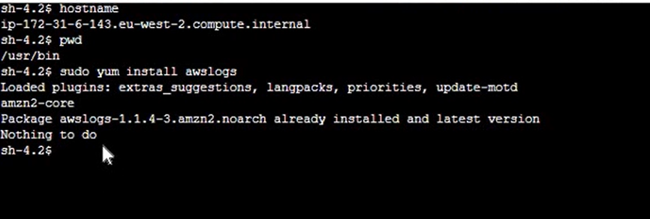

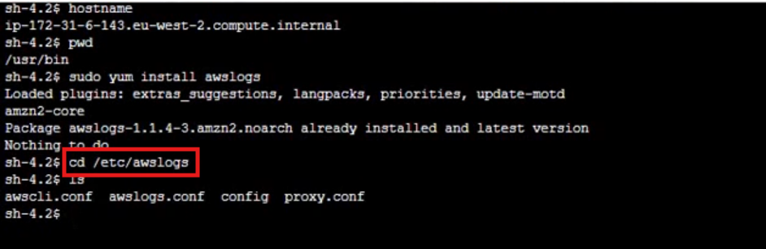

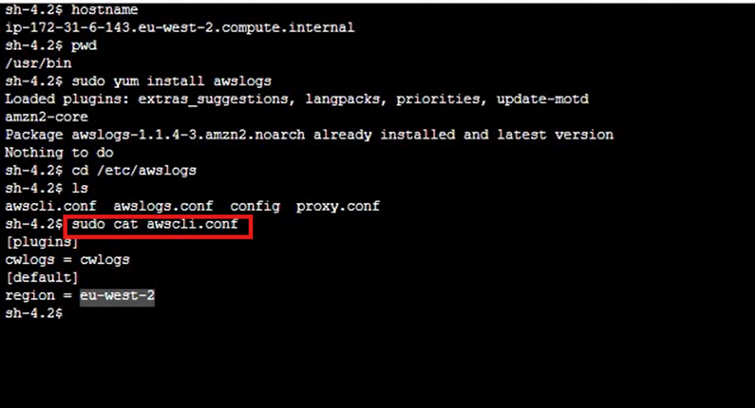

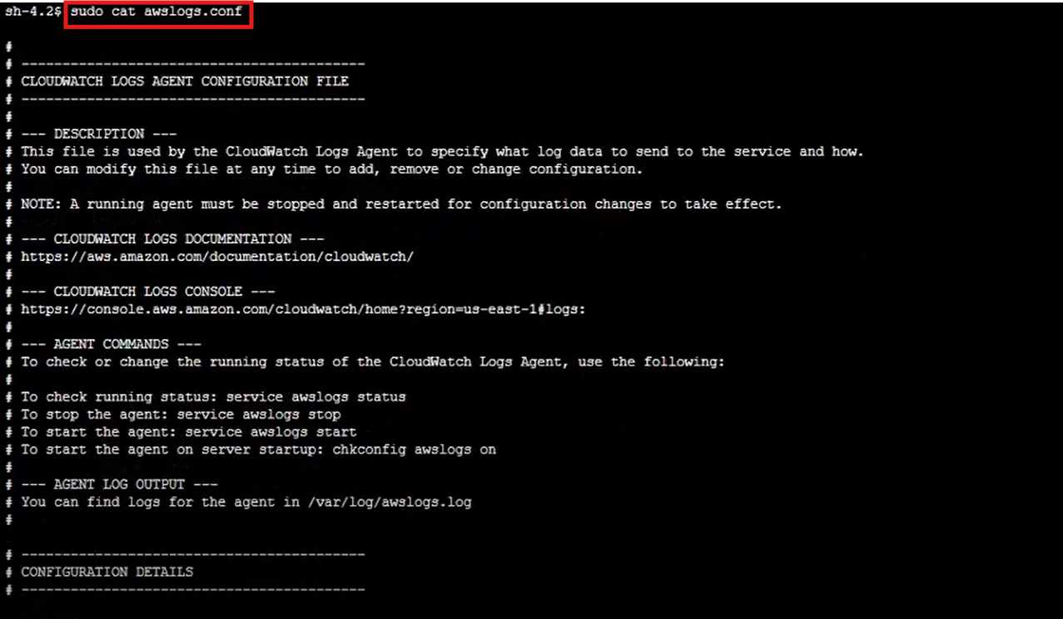

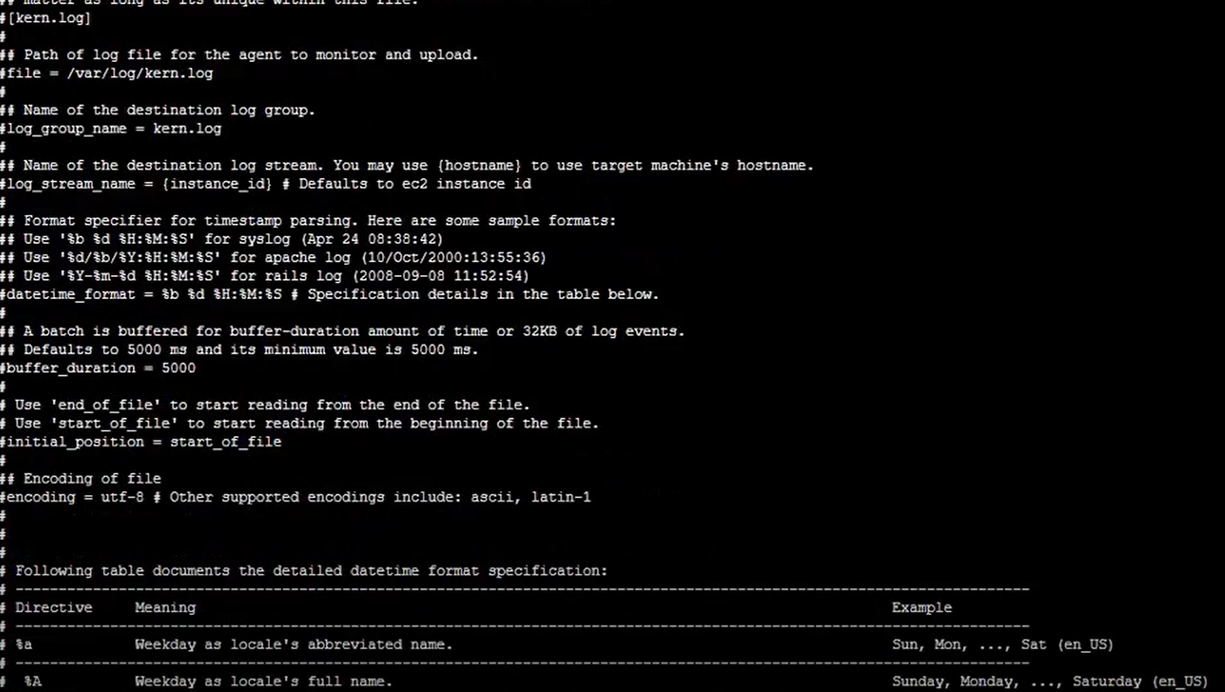

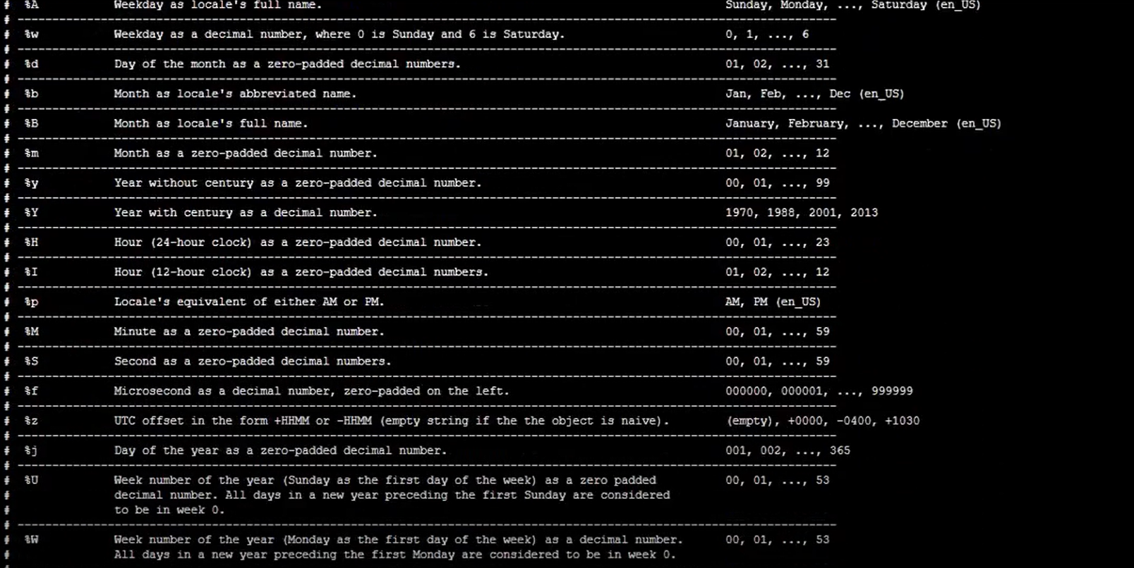

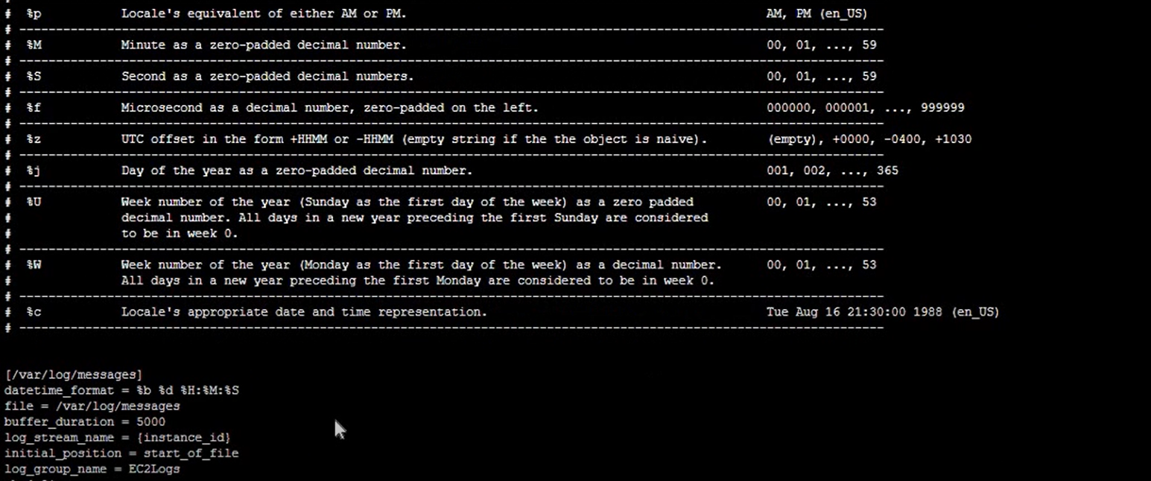



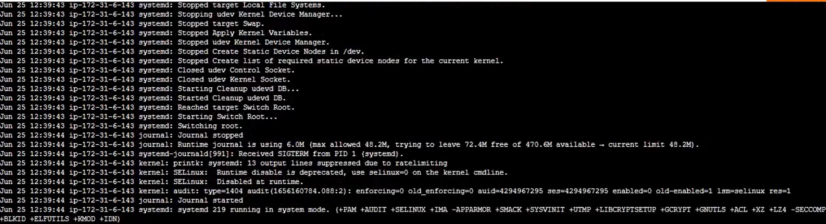

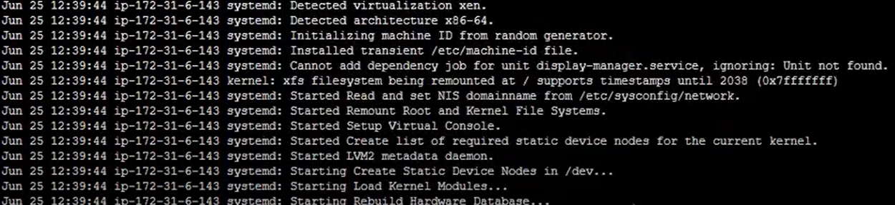

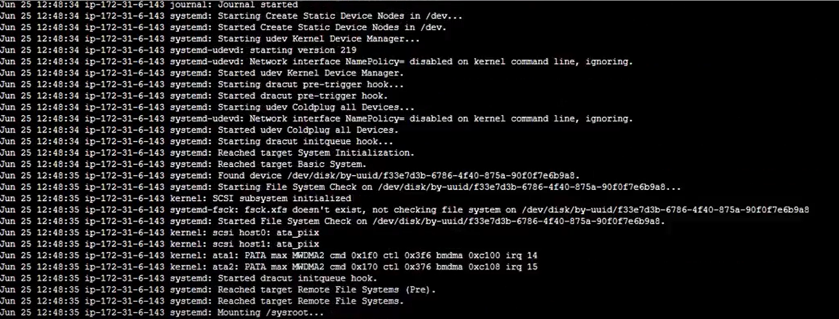

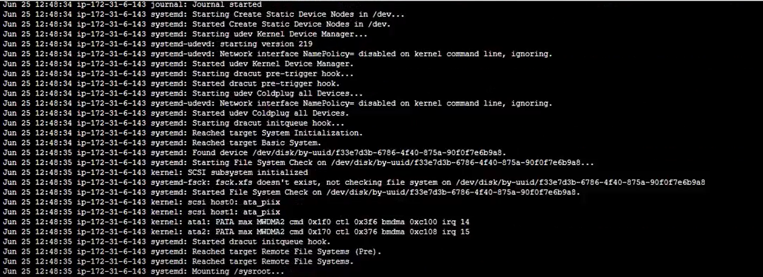

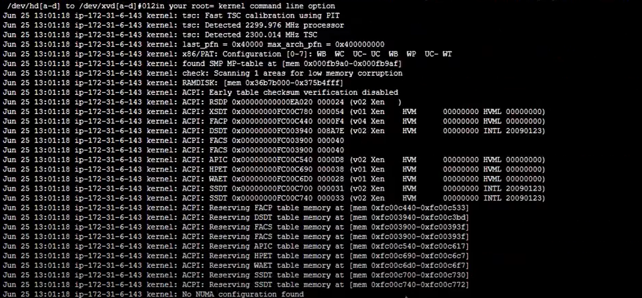

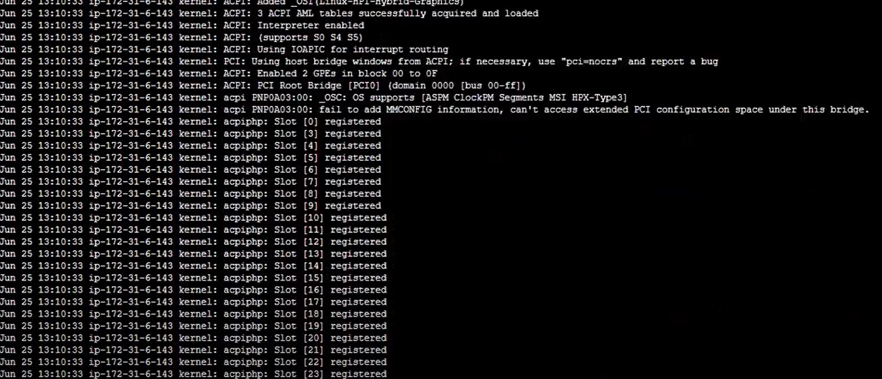

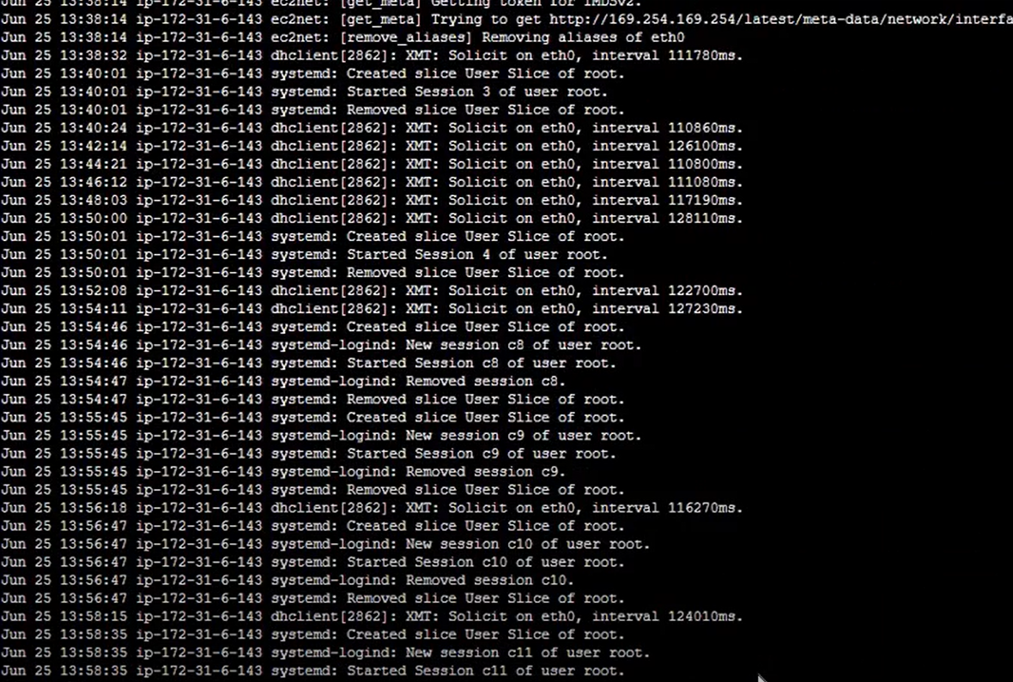

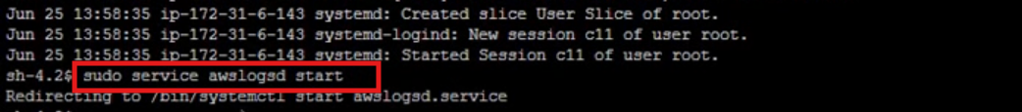

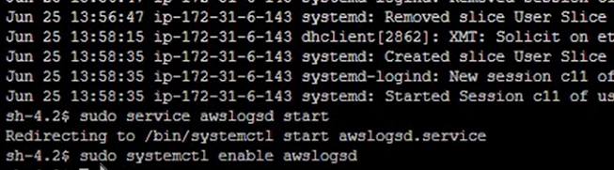

* Log groups has been created

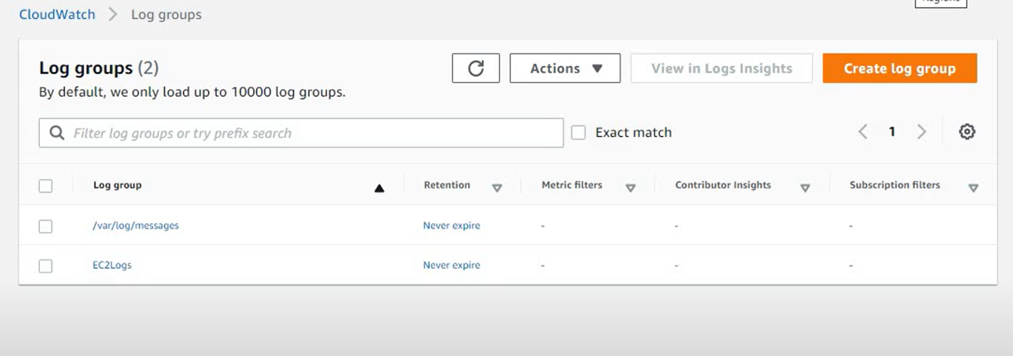

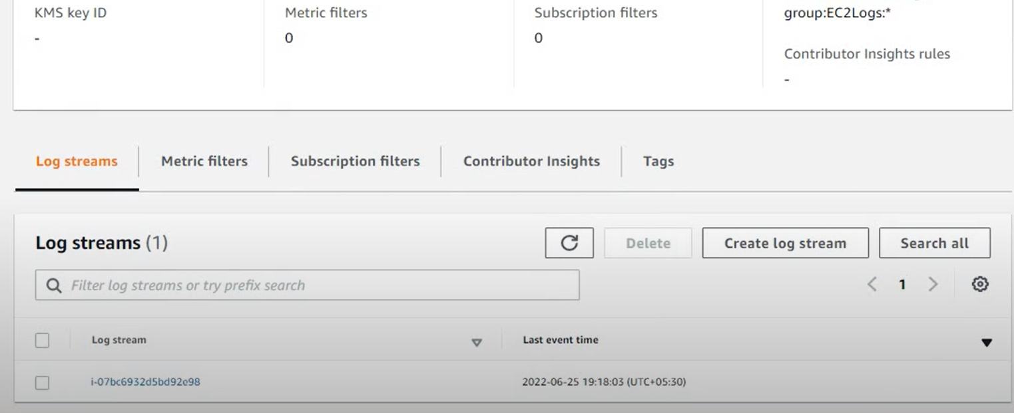

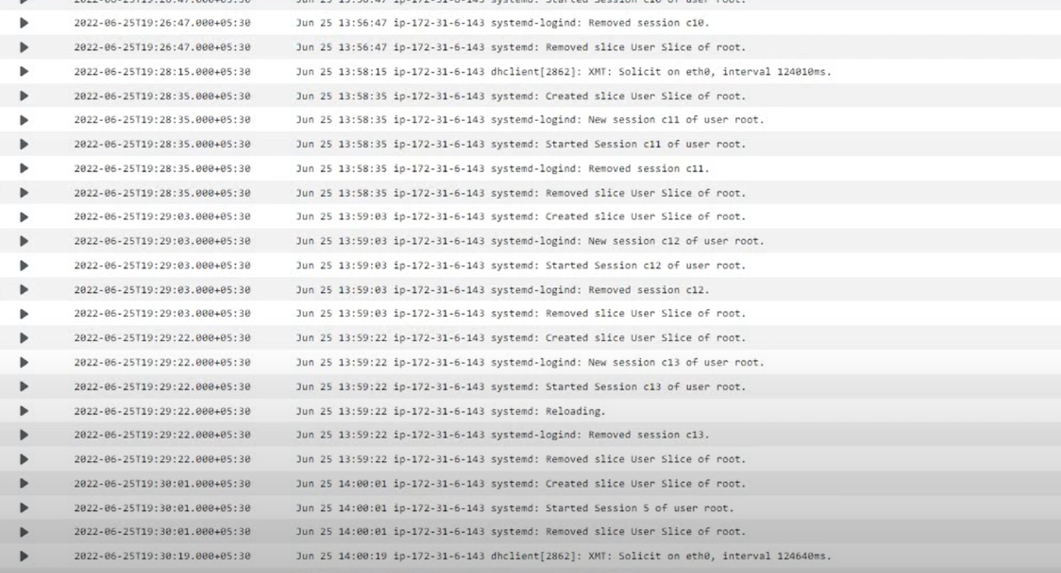

* Exporting the logs to S3 bucket.

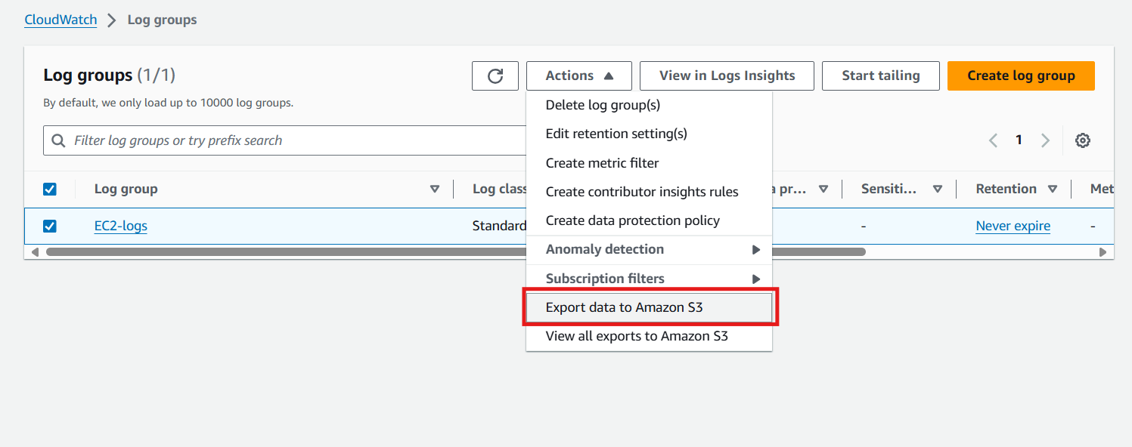

Creating S3 bucket.

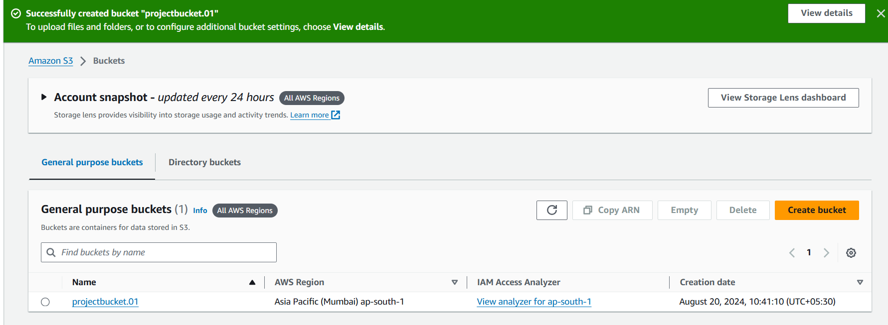

* Give permissions to S3 bucket for writing the logs.

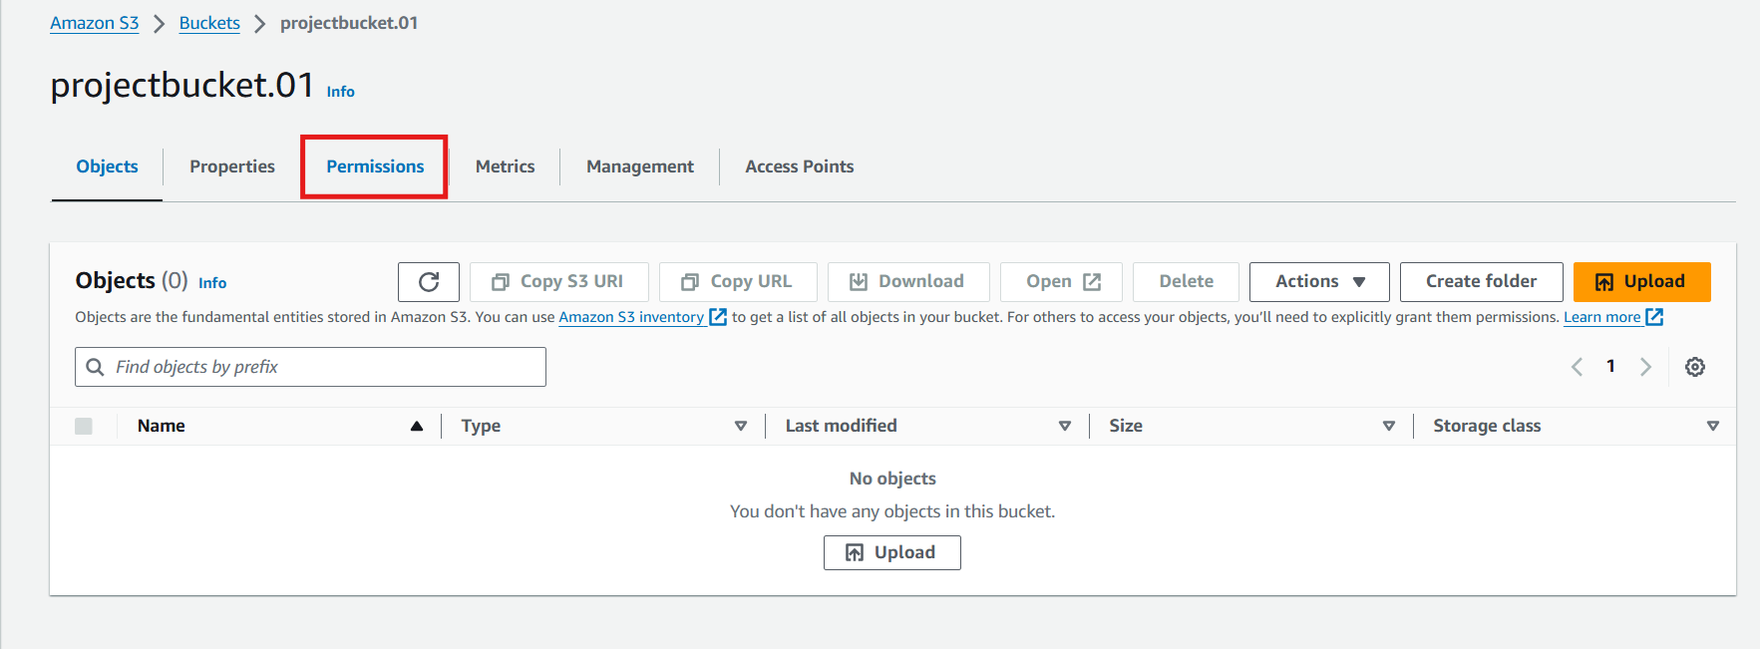

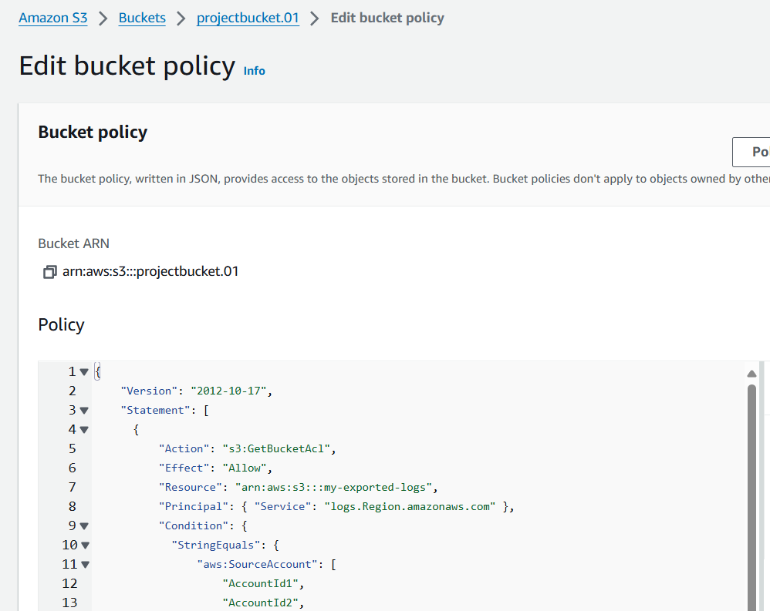

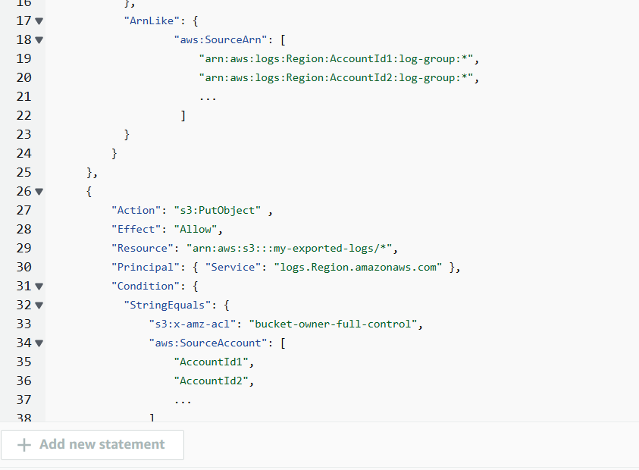

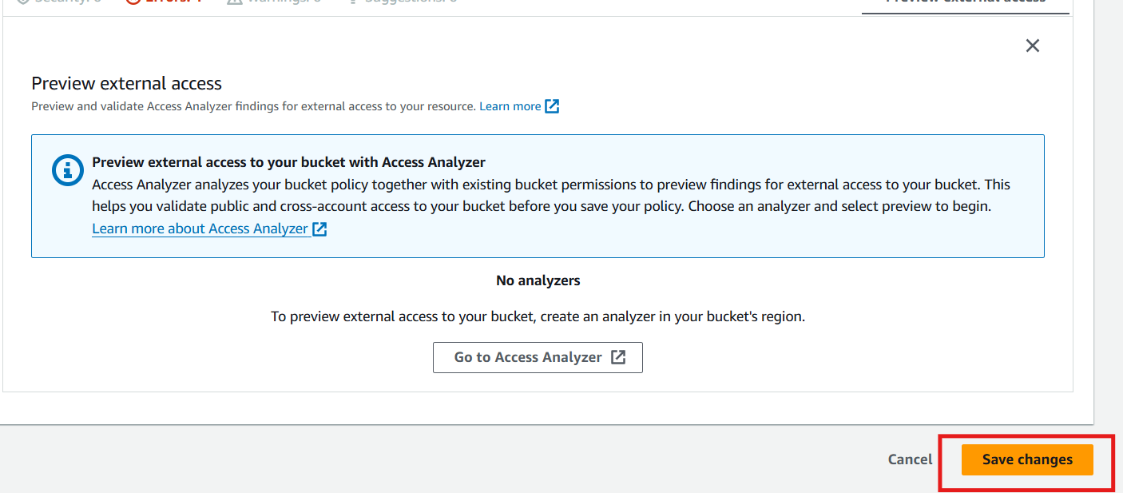



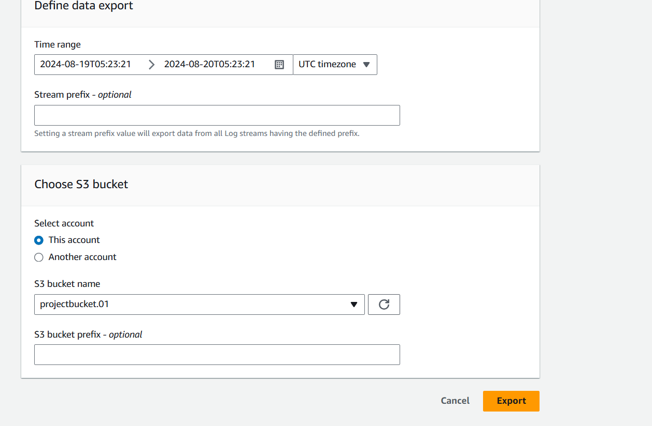

Now, Our logs are successfully exported to the S3 bucket.

#### **CONCLUSION**

### **PROBLEM STATEMENT:**

* **Log Storage and Management:**

**Issue:** Running out of disk space on the EC2 instance due to log files.

**Solution:** By exporting logs to an S3 bucket, you can offload log storage from the instance, freeing up disk space and reducing the risk of running out of storage.

* **Log Analysis and Insights:**

**Issue**: Difficulty in analyzing and gaining insights from log data due to its volume and complexity.

**Solution**: By exporting logs to an S3 bucket, you can use AWS services like Amazon Athena, Amazon Redshift, or Amazon QuickSight to analyze and gain insights from log data

* **Log Security and Compliance:**

**Issue**: Ensuring the security and integrity of log data to meet compliance requirements.

**Solution**: By exporting logs to an S3 bucket, you can leverage AWS's built-in security features, such as encryption at rest and in transit, to ensure the security and integrity of log data.

* **Log Retention and Archiving:**

**Issue**: Managing log retention and archiving policies to meet regulatory requirements.

**Solution**: By exporting logs to an S3 bucket, you can set up log retention and archiving policies to meet regulatory requirements, such as retaining logs for a certain period or archiving them for long-term storage.

* **Instance Performance and Resource Utilization:**

**Issue:** High resource utilization on the EC2 instance due to log generation and storage.

**Solution**: By exporting logs to an S3 bucket, you can reduce the resource utilization on the instance, improving its performance and reducing the risk of resource bottlenecks.

* **Log Centralization and Aggregation:**

**Issue:** Difficulty in centralizing and aggregating log data from multiple sources.

**Solution:** By exporting logs to an S3 bucket, you can centralize and aggregate log data from multiple sources and make it easier to analyze.

Thank you